Tēnei te mihi ki a koutou katoa. Nau mai, haere mai, whakatau mai.

Warmest greetings to our members and supporters throughout Aotearoa and Australia. This is the third of our three editions of ‘He Purongo’ which are devoted to updating members and supporters about our conference. In this edition we have:

- Notice of General Meeting.
- Te Kahui Tumuaki Elections 2021 reminder.
- Call for Remits
- KMA Wellington Biennial Conference Registration reminder.
- KMA Members Painless Payments Options reminder.
- Tangata (Financial) Membership Subscription reminder.
- Important Dates to Remember.
- Contact Details.
- MTK Wananga.

We would like to thank all members who have called, registered, part paid, fully paid and submitted nominations so far. Registrations, nominations and submittions are still open, so please take this opportunity to join us in September and to have your say on the ongoing growth of Kāpō Māori Aotearoa.

Don’t hesitate to phone or email us if you have any questions about any of the items in this panui.

Ngā mihi nui
Chrissie and KMA team

Notice of General Meeting

Notice is hereby given to 2019-2021 Tangata (financial) Members that the 2021 General Meeting of Kāpō Māori Aotearoa New Zealand Inc will be held at 9.00 am, Saturday 11th September at the Copthorne Hotel, Oriental Bay, Wellington.

Agenda:
Karakia/Mihimihi
Roll Call
Apologies
Confirmation of 2019 General Meeting Minutes
Matters Arising from Minutes
President’s report
Financial report
Te Kahui Tumuaki Elections
Remits
Annual Subscription
Biennial Conference 2023
General Business
Karakia

Gaylene Te Rauna, President.

Te Kahui Tumuaki Elections reminder

Friendly reminder that Kāpõ Māori Aotearoa, (KMA), Board Elections are open for nominations. The following three (3) positions are up for election:

- President
- Executive Member
- Executive Member

Tangata members are also invited to submit nominations for the following position:

- Vice President

The term of this position will be two years commencing from 11th September 2021.

Only Tangata (financial) members can nominate candidates and vote. More information, refer ‘Tangata (Financial) Membership Subscription reminder’ in this panui.

To nominate someone or be nominated, please complete the ‘Nomination form’ and return to the Board Secretary, Tarewa Cowan, either by email or post, by 5pm on Friday, 9th July 2021

Election results will be announced at the KMA General Meeting Saturday, 11th September 2021.

For more information, please refer to the ‘Contact Details’ section at the end of this panui.

Call for Remits

Tangata members are invited to submit remits by no later than 5pm, Friday, 20th August 2021 to the Board Secretary, refer #9 Contact Details. All remits will be considered at the KMA General Meeting 11th September 2021.

Note.

A remit is a statement submitted for consideration, which can either seek policy change (policy remit) or change to the KMA Constitution (constitutional remit).

KMA Wellington Biennial Conference Registration

Conference registrations are now open and can be done online -‘Survey Monkey’ link can be found on our Facebook and website. You must be registered to attend BC 2021. Please refer to the ‘Contact Details’ section for more information or requesting registration are listed at the end of this panui.

We encourage KMA members to register early - due to COVID-19 guidelines, delegate numbers are limited to 60 spaces. The closing date for registrations is Friday, 30th July 2021 or until places have been filled.

KMA Members Painless Payments Options reminder

Some members are already utilising our ‘Painless Payments’ options, which offers you the choice to pay your KMA Tangata subscription and conference registration fee by instalment - either weekly, fortnightly, or one lump sum. Please refer to the ‘Contact Details’ section for more information about these payment options.

Full payment of KMA Tangata subscription and BC2021 Delegate fee is due by 5pm, Friday, 20th August 2021.

Tangata (Financial) Membership Subscription reminder

The annual Tangata (financial) membership fee is $20.00 (18 years and over). To be eligible for the Tangata member conference fee you must have been a financial member for two years (2020 and 2021).

KMA is a registered charity (#CC 492600) which entitles Tangata members to claim a tax reimbursement from the IRD. Please refer to our social media, on Facebook and www.kapomaori.com for more information.

KMA Tangata Member Biennial Conference benefits include:

- Biennial Conference Tangata Delegate fee.
- Participating in Te Kahui Tumuaki election – nominating and voting.
- Submitting and voting on remits and motions at the KMA General Meeting.
- Nominating KMA Life and/or Honorary Members.

Important Dates To Remember

- Friday, 9th July 2021, 5:00pm: Te Kahui Tumuaki nominations close.
- Friday, 30h July 2021: BC2021 registrations close.
- Friday, 30th July 2021: Nominee Profiles and Voting papers sent to Tangata members.
- Friday, 20th August 2021, 5:00 pm: Remit(s)/motions close.
- Monday, 2nd August 2021: Te Kahui Tumuaki Board ballot voting opens
- Wednesday, 30th August 2021, 5:00 pm: Te Kahui Tumuaki Board ballot voting closes - Voting papers returned and collated.
- Friday, 10th to Sunday, 12th September 2021: KMA Biennial Conference.
- Saturday, 11th September 2021: KMA General Meeting.

Contact Details

Information requests, conference forms, registration and or renewal of Tangata membership:
- Freephone, 0800 770 990 or
- Email info@kapomaori.com

Te Kahui Tumuaki General Election, nominations and remits:
- Board Secretary email: tarewa.cowan@kapomaori.com
- KMA Postal address: Kāpō Māori Aoteaora, PO Box 933, Hastings 4122.

Kāpõ Māori Aotearoa Social Media Channels:
- Website: https://www.kapomaori.com/
- Facebook: https://www.facebook.com/KapoMaoriAotearoaNZ

MTK Wananga

During the month of June, MTK completed their second wananga which included hosting Minister Sepuloni, attending the Access Alliance Peoples’ Choice Accessibility Awards 2021 and doing a field trip to the Ombudsman NZ Auckland office to learn more about the role of the Ombudsman Disability Rights team.

Te Kahui Tumuaki are pleased to support MTK’s decision to be Access Alliance champions and congratulate MTK members for representing KMA and our kaupapa.

To follow their adventures throughout Aotearoa, go to their facebook page: https://www.facebook.com/MTK-1925760917484567/

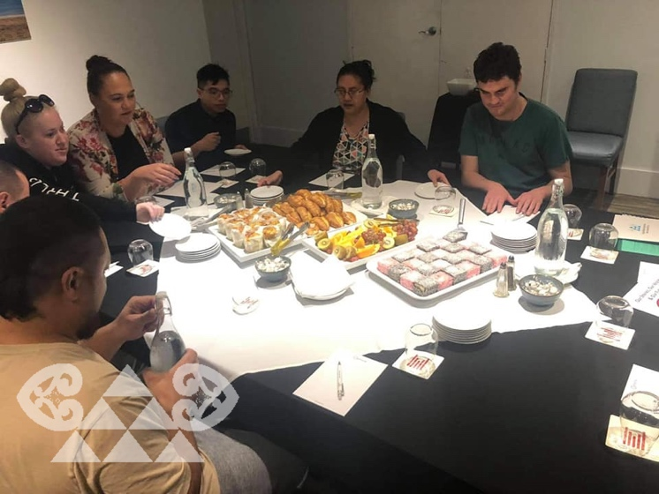
Afternoon tea with Minister Sepuloni
MTK members and Minister Sepuloni at the Access Allliance Peoples' Choice Accessibility Awards 2021

MTK and Ombudsman NZ Disability Rights Team

