He Pūrongo – Winter 2018 Edition
Nau Mai, Haere Mai!

Ngā mihi nui to our members and supporters throughout Aotearoa and Australia.

In 2017 the team at Kāpō Māori Aotearoa New Zealand decided it was time for a fresh look for our panui, He Pūrongo. We wanted to take the opportunity to highlight achievements and opportunities our wider KMA whānau have undertaken and share their experiences in their own words.

This edition includes:
- Hannah Pascoe, World ParaCycling Championships, Rio de Janiero
- Wiremu Kohere, Outward Bound, Anikawa
- Rangatahi Think Tank Hui, Rotorua
- Regional member and Tangata Whaikaha Whānau Hui
- Biennial Conference 2019
- Staff and Event updates

We hope you enjoy its contents and if you would like to share your experiences, please get in touch by phoning 0800 770 990.

2018 Para Track Cycling World Champs, Rio De Janero
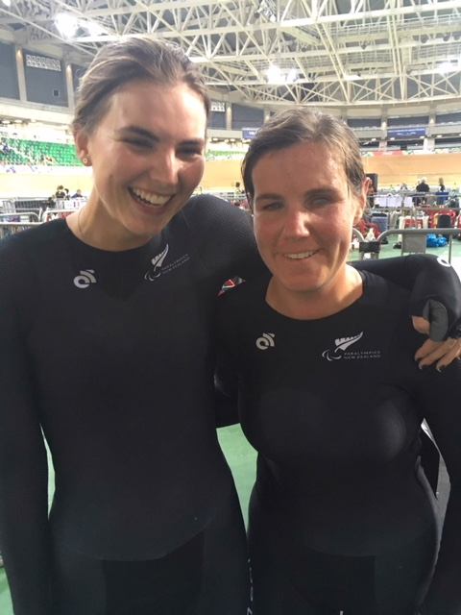
Written by Hannah Pascoe
Photo: Nina and Hannah at the Rio de Janiero Velodrome

I’d like to take this time to thank Kapo Maori Aotearoa New Zealand, for the support and to those of you who followed the event. When you are so far away from home, it came as comfort, knowing you were all there keeping watch through the social media avenues, so with me in spirit.

The entire experience from our pre-camp in Cambridge to being in Rio was overwhelming. I can’t tell you much about Rio itself as in a high performance environment you are race-focused without time to really experience another country. One day I hope to return and explore more as the glimpses we did have were fascinating. A few of my highlights included visiting the Rio Olympic Velodrome for the first time knowing that the Olympics were held in the very spot in 2016 and getting to touch the medals won by other Kiwis. The other highlight was briefly meeting other athletes from other countries. Though we couldn’t speak the same language, we found a way to communicate.

Racing itself was an emotional experience as unlike other sporting events, this was about competing to win and meet your race goals while representing your country. Given it was my first world stage event and for Nina (pilot), her first time racing tandem on the world stage, we managed to take out fifth spot in the world for tandem. Our best event was match racing where we had to ride neck-neck with another tandem for six laps and be the first to cross the line. I loved riding this track!

Outward Bound Insight Course, Anakiwa
Written by Wiremu Kohere
Photo: Wiremu Kohere

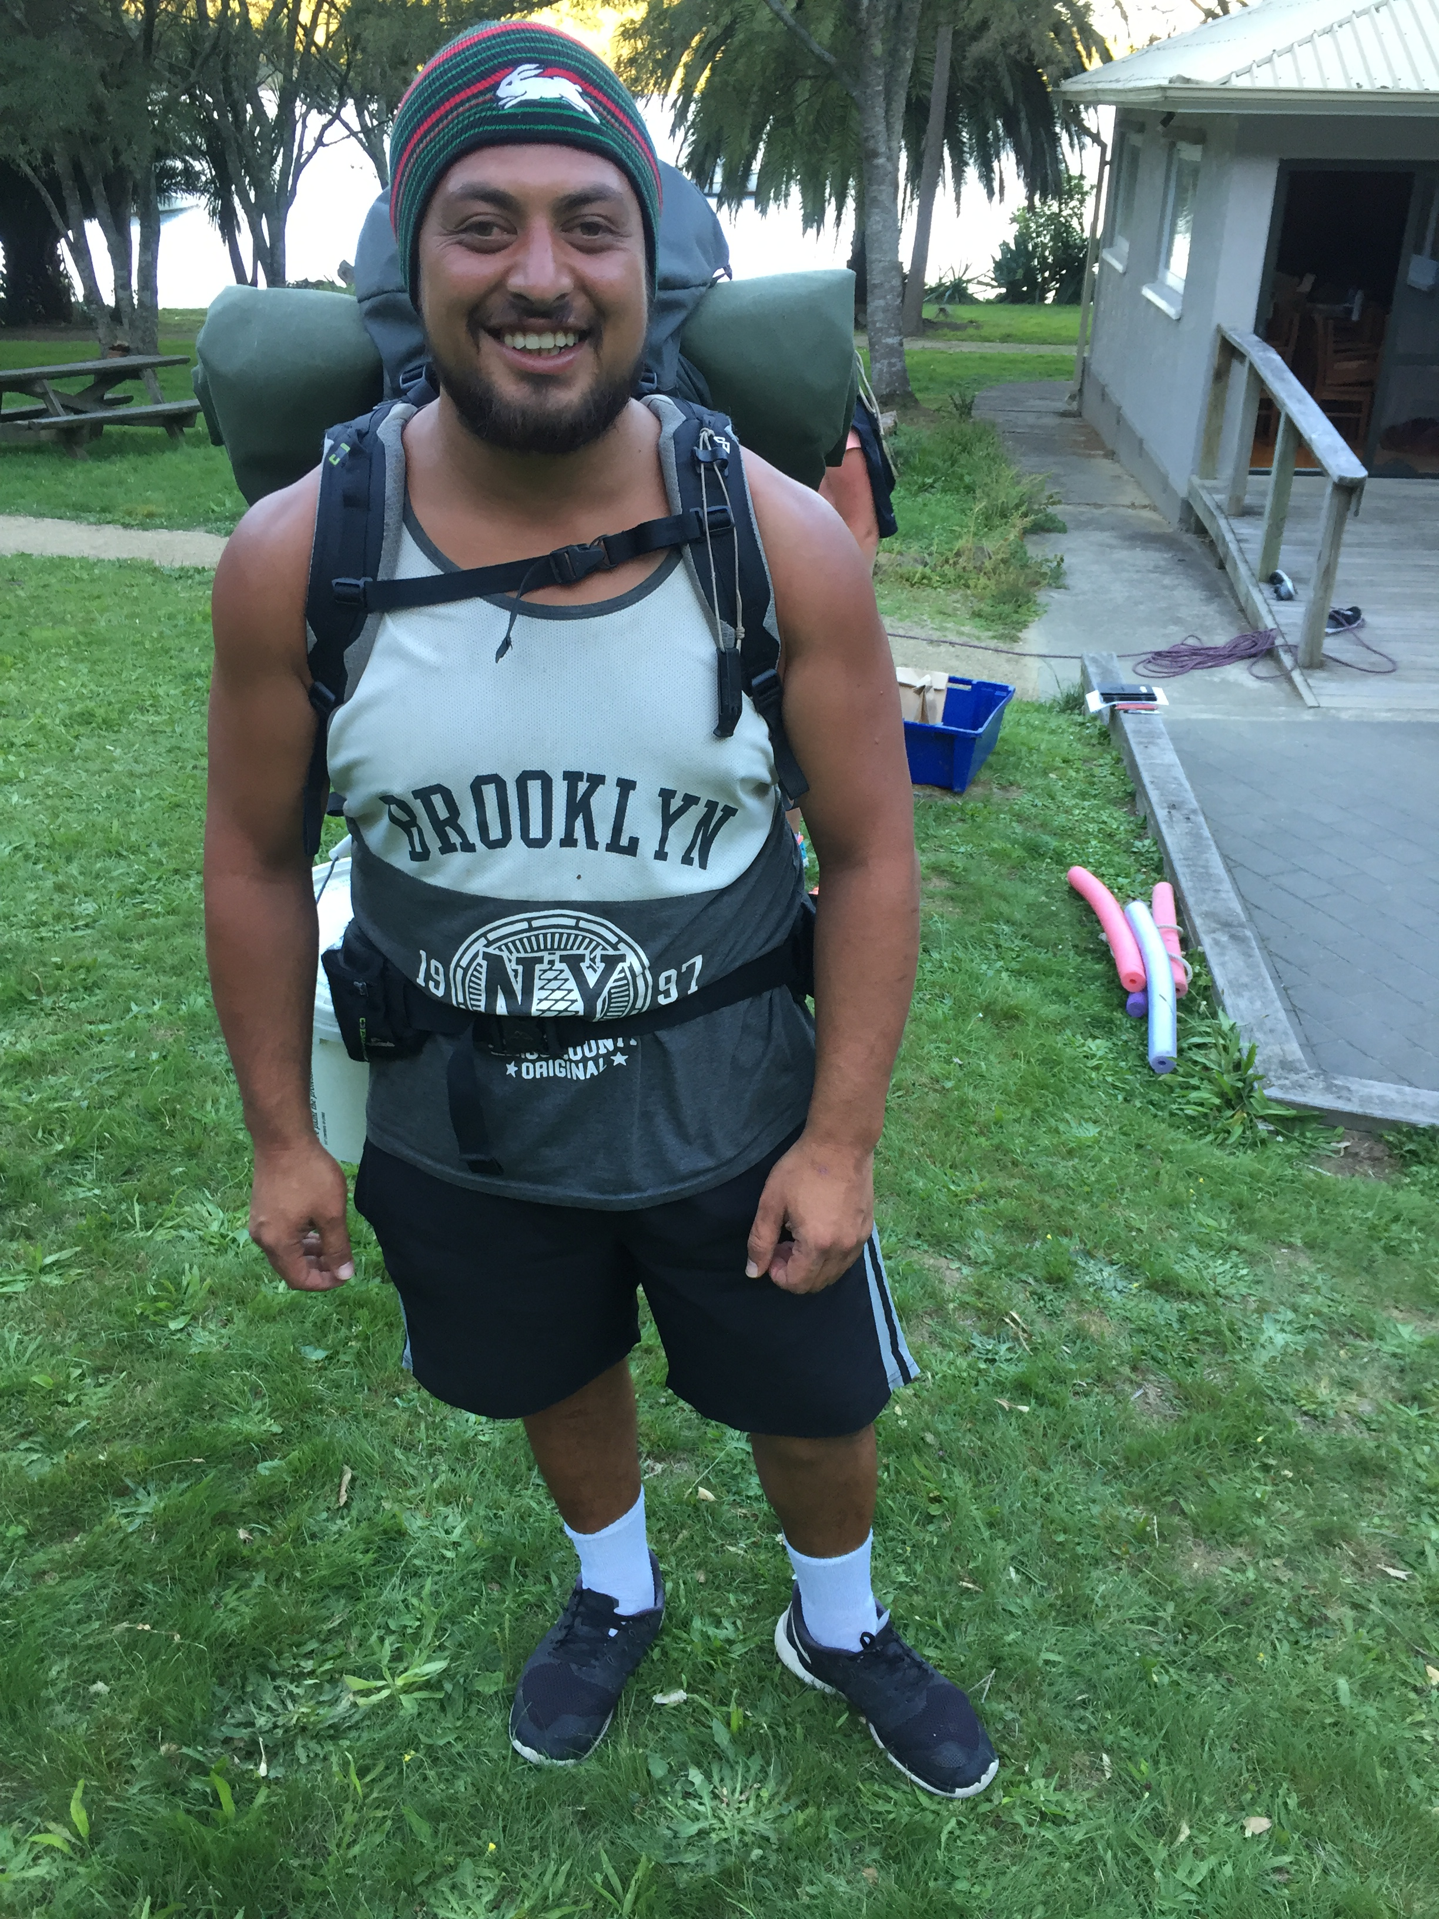
Kia Ora koutou, my name is Wiremu Kohere, I live in Tauranga and I'm a Tangata member of Kāpō Māori Aotearoa New Zealand.

From the 2nd to the 9th of March, I participated in the 2018 Outward Bound Insight course down the South Island at Anakiwa. I have to say participating in the Outward bound Insight course was the best experience of my life.

My favourite parts was captaining the sailing boat on rough seas and conquering my fear of heights on the high ropes and also sneaking feed of mussels and Tuangis while swimming. It was fun, exciting, scary, challenging and many other emotions. Not only did we do amazing activities but we also learned important routines and habits like staying active, cleanliness, eating and exercise routines, all to make our lives happier, healthier and more positive to share with our whānau and friends.

I learned to believe in myself, eat healthier, exercise regularly, respect all people and the environment, working together as a team, communication skills, leadership skills, how to survive on my own for 21 hours in the bush as well as all the skills I learned doing sailing, hiking/tramping, high ropes, building raft/rafting, kayaking, swimming, and social interactive activities to improve our ability to communicate and participate better in life.

These experiences will help me move forward in life because I'm more confident in myself, I've learned that I can do anything I set my mind to so try new things and face challenges outside my comfort zone head on and conquer them to achieve success.

A quote I found in a book I've read from outward bound says; "I am only one, but I am one. I cannot do everything, but I can do something. And I will not let what I cannot do interfere with what I can do". I really enjoyed this quote and many more because it reflects some of the feelings that I felt leaving outward bound. Full of self belief, sense of achievement and most of all Whanaungatanga, sharing this amazing experience with incredable people who I now call my whanau.

Nga rangatahi Kāpō Māori Aotearoa, I highly recommend doing outward bound to you all because the benefits of doing this course are awesome. Lots of fun and adventures in a beautiful location, you get fed really well, meet positive and supportive people, kick away bad habits/routines and start new good ones. A great opportunity to create a better you no matter what disability you have. The positiveness of outward bound staff will pull you in and change your outlook on life forever if you accept the outward bound challenge.

One last quote from a book called 'the challenge of words' from outward bound says: "The pessimist looks at opportunities and sees dfficulties; The optimist looks at difficulties and sees opportunities."

I'd like to give a huge thank you to Kapo Maori Aotearoa and The Blind Foundation for making my participation in the course possible. I really appreciate your help and I promise to give my all in my new bicultural social services course and in life.

THANK YOU.

Young Adults Think Tank Hui, Rotorua
Photo: Keretina, Tash, Gaylene, Tamatea, Jamus, Tamati, Chrissie, Wiremu

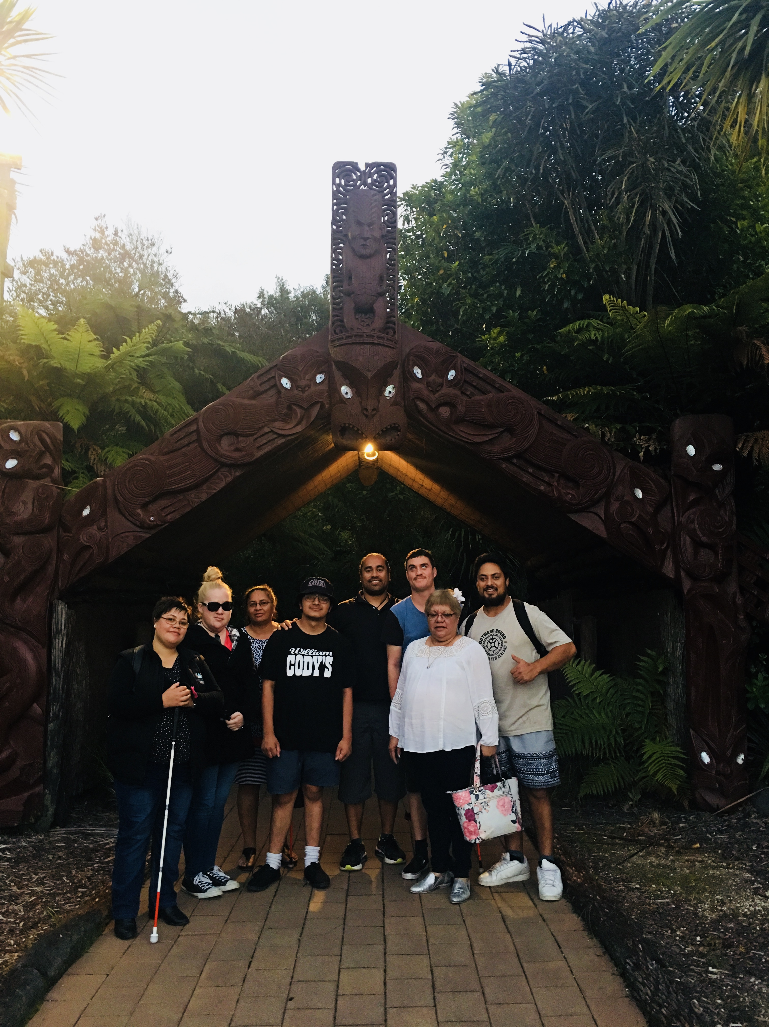
A total of five young adults attended the inaugural Think Tank Hui held in Rotorua on Monday 26 March 2018; we appreciate and acknowledge their attendance, Wiremu Kohere (Tauranga), Tamati Pearse (Auckland), Tash Swann (Hamilton), Keretina Ransfield-Mutu (Tokoroa) and Tamatea Chambers (Wellington).

During this hui they confirmed support to learn and interact with Kāpō Māori Aotearoa by:
- Learning about Governance and Operations
- Setting up a ‘Young Adults’ rōpu as a platform to discuss issues and work collectively on finding solutions
- Exploring opportunities for internships, and
- Playing a lead role in the 2019 Biennial Conference.

The rōpu identified a goal to meet with Minister Willie Jackson to speak directly about the barriers and issues they face gaining employment. To end their time together, the group spent time at Tamaki Māori Village in Rotorua, special thanks to Jamus Webster for setting this up.

A follow-up hui will be held in June with the North Island Young Adults rōpu to progress their goals and draft a workplan with a South Island Young Adults think tank hui planned for July.

Biennial Conference 2019 Update
It was reported in the December Panui, that the 2019 Biennial Conference would be hosted in Gisborne, Tairawhiti. Unfortunately, since then, it became apparent that there were insufficient facilities that could meet our particular requirements.

Therefore, Te Kahui Tumuaki are pleased to advise that the Biennial Conference will be hosted in Ahuriri, Hawke’s Bay, with the dates being Thursday 6 to Saturday 8 September 2019.

Regional member and Tangata Whaikaha Whānau Hui
Photo: Tauranga Rōpu Hui

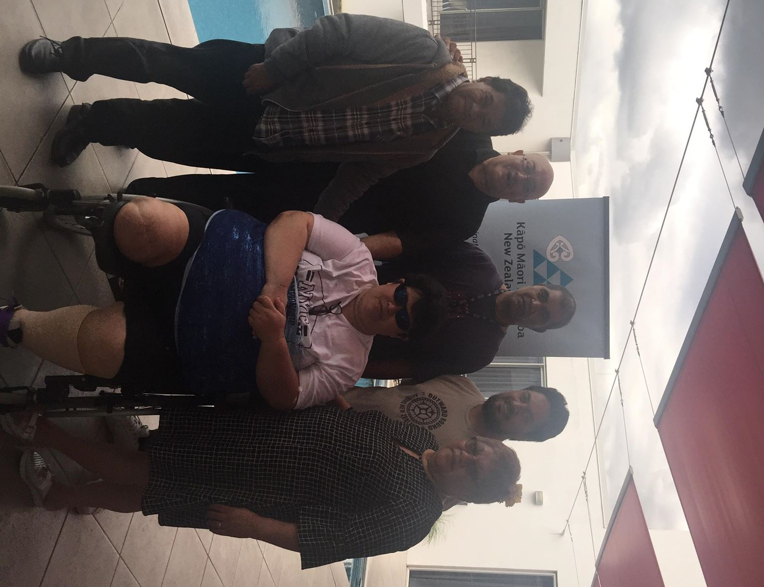
In March 2018 two regional hui were held in Whakatane and Tauranga. These were led by the CEO who was accompanied by Tangata Whaikaha Kaimahi, Horiana MacGregor. The hui was an opportunity to meet with regional members and provide updates with KMA events, Biennial Conference and to promote the Tangata (Financial) Membership and Tangata Whaikaha Network.

Further hui are planned for Christchurch and Hastings during July and August.

WHAT WE’VE BEEN UP TO…
- Staff Training
The Operations team held a three-day training in April in Hastings, covering Communications Training and successfully completing the St John Level 1 First Aid Certification. In May, the team came together in an online training course for the organizational case management system, Exess.
- Vision Assessments and Re-Assessments
The Field team have been travelling throughout Aotearoa to meet with members requesting specialist vison services in conjunction with the Blind Foundation. If your circumstances have changed or you have requests for support, please phone our 0800 free phone number, 0800 770 990.
- Surveys
Two surveys will be completed in June and July. The Disability Information and Advice Service (DIAS) and Specialist Maori Cultural Support Service. We look forward to catching up with you during this time.
What’s Coming Up
- June – Young Adult Think Tank, Rotorua
- July – Young Adult Think Tank, Christchurch
- July and August – Regional Hui, Christchurch and Napier
- August – Te Kahui Tumuaki Board Meeting
- September – Staff Training and Meeting with BLENNZ, Auckland

