Ngā mihi o te Kirihimete me te Tau Hou

This, the second volume of our three ‘Reflections’ panui, highlights events that occurred during the period January to June 2022.

Panui Release Dates

The final volume of the ‘Reflections’ panui and the ‘Looking forward 2023’ panui will be distributed on the following dates:

- 30th December 2022: Reflections - July to December 2022
- 6th January 2023: Looking forward 202

Please feel free to share our panui with your whānau and through your networks.

We take this opportunity to thank you all for your support and contributions during 2022 and we look forward to catching up with you in 2023.

Have safe and relaxing Christmas and New Year.

Te Kahui Tumuaki and staff

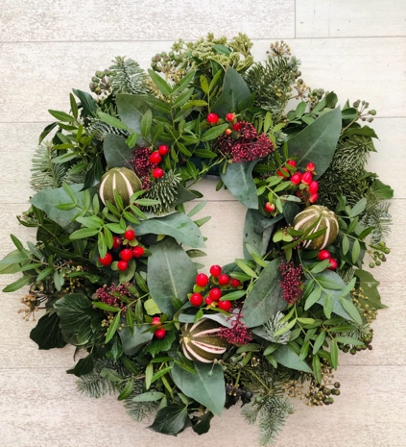

- He Rau Aroha: Patric Cowan (25 August 1957 to 26 January 2022)

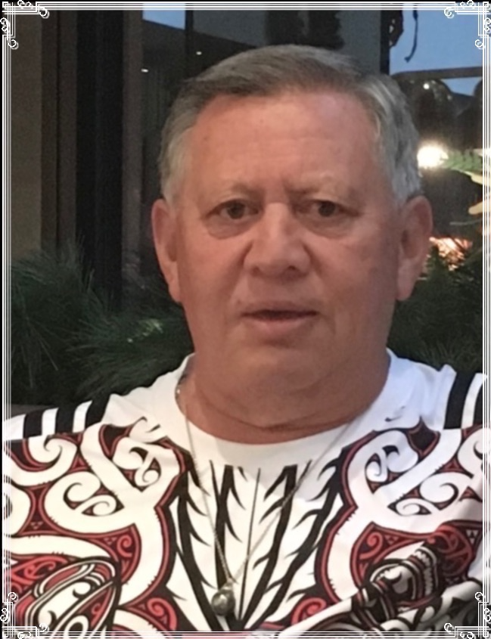
E Patric, Ka tangi moteatea te ngakau ki a koe, kua mawehe i te pai o Autahi, kua rauika atu ki tua o paerau. Whakarehu tahi atu koutou ki te huinga o te kahurangi ki te kapunipunitanga o ngā wairua.

On 26 January 2022 beloved husband of our Chief Executive, Chrissie Cowan and adored father of our Board Secretary, Tarewa Cowan passed away suddenly in Hastings.

Of Tahitian, Cook Island, Chinese and Scottish descent, Patric was born on the island of Tahaa, located in the western part of the Society Islands of French Polynesia, located in the east of the Leeward island group which includes Maupiti, Tupai, Raiatea, Bora Bora and Huahine Islands.
Photo 1: Patric Cowan

Patric’s relationship with KMA started in 1990 when Chrissie was appointed personal assistant to the Manager Māori Services, Royal New Zealand Foundation of the Blind. A passionate volunteer, Patric helped out where needed - driver, sighted guide, cook, kitchen hand and drinking buddy.

His generosity of spirit and kindness extended to supporting Chrissie’s whānau, hapū and Iwi and as a security officer at the Hawke’s Bay district hospital, working tirelessly to protect and ensure the safety of patients and staff. He shared his professional experiences freely, this including his linguistic abilities speaking French, English, Cook Island, Tahitian and Te Reo Māori fluently.
During his tangi many spoke of Patric’s adoration and pride in his wife and daughter’s achievements. Patric left Tahiti to join Chrissie in Aotearoa in December 1989 and on 6 January 2022 they celebrated their 32nd wedding anniversary. Right up to his passing, it was obvious to all the respect and devotion that Patric and Chrissie had for each other and that he was a besotted father always willing to drive Tarewa to the gymn, events and support her to pursue her dreams.

Patric loved Aotearoa but remained staunch to his indigeneity, he was Tahitian hard out. He never forgot the reo of his birth island or the other islands of French Polynesia, the tikanga of his people and the values instilled in him by his whānau in Tahiti.

Chrissie and Tarewa convey their sincere thanks and appreciation to all those people and organisations who sent messages of condolence, flowers and tributes.

Te Kahui Tumuaki thank KMA members, staff, supporters and allies for enabling Chrissie, Tarewa and KMA to grieve the loss of Patric. The Board also conveys their sincere condolences to Putiputi and Joseph Twomey at the loss of their son, the Witana and Stevens whānau at the passing of Alan and Isobel Witana and all KMA whānau who experienced the loss of whānau during 2022.

Kua rurutu a roimata, kua maringi a hupe, ai ngā mihi me ngā tangi. Waiho mai ai te hunga ora ki muri hei urupā ora mo tana me o tana wawata, o tana moemoea.

Tenei te tuku atu rā i ngā mihi aroha ki te whānau pani a ki i pania nei e kapua pouri i marama ake nei. Ko te tumanako ka māturuhia mai e te wāhi ngaro te tōmairangi o tōna ngākau atawhai ki runga i a koutou i tenei wā.

- Tangata kāpō Māori Complaint

In August 2021 six kāpō Māori lodged individual complaints against the RNZFB Board and requested KMA act as their advocate. Claimants stated the RNZFB Board of Directors failed in their duty to recognise and respect Te Tiriti o Waitangi articles rangatiratanga, kawangatanga, oritenga. Specifically the right to have:

- Tangata whenua, youth and Pasifika representation on the RNZFB ‘Board.
- Access information in Te Reo Māori.
- Inclusion and consultation in RNZFB Board decision-making processes.
- Lack of equity and transparency in the RNZFB Governance Board election protocols.
- Discriminatory behaviour towards not only Māori and Pasifika peoples but also towards those who are able-bodied.

In February 2022 a mediation hui was held between the claimants and RNZFB Board members in Wellington. At this hui RNZFB Board Directors made a commitment to draft an action plan for the consideration of the claimants by 10 March 2022.

The RNZFB Board neither followed through on this commitment or provided an explanation for their non-action. In an effort to obtain answers, claimants submitted questions which were tabled and responded to by the RNZFB Board during the Q&A session of the RNZFB Board AGM on 2 December 2022. The response of RNZFB Board Directors was they would discuss the issues raised at their February 2023 retreat.

Given the on-going disrespect of the rights of the claimants and KMA members generally, Te Kahui Tumuaki published a press statement requesting that RNZFB Board members voluntarily stand down so to enable a review of the RNZFB constitution, governance policies and practices. The statement was posted on KMA social media platforms and distributed to members and supporters. A copy of the statement can be obtained through phoning the KMA 0800 770 990 freephone or by email request to info@kapomaori.com.

We take this opportunity to acknowledge the statement published by Parents of Vision Impaired and messages of support from individuals and human rights agencies.

Footnote. Since the 2 December 2022 RNZFB AGM, the RNZFB Directors have made no attempt to contact claimants via their advocate or KMA Te Kahui Tumuaki.

- Signing of Tatou Pounamu with RANZCO

On the 15 July 2022 Te Kahui Tumuaki signed a tatou pounamu (Memorandum of Understanding) with the Royal Australian and New Zealand College of Ophthalmologists (RANZCO) to work in partnership to improve the future of Māori eye health in Aotearoa. The signing held at ‘Auckland Eye’ established a working group to work collaboratively on developing, implementing, monitoring and evaluating the ‘Te Tiriti o Waitangi Action Plan’, a Māori centred approach to improve Māori eye health and wellbeing in Aotearoa.

Photo 2: (From left to right) Dr Justin Mora (RANZCO), Chrissie Cowan (CE, KMA), Professor Nitin Varma (RANZCO President) and Nigel Ngahiwi (KMA President)
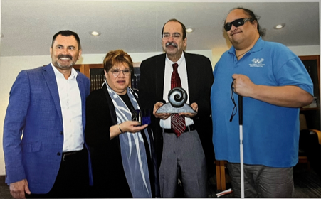

- Research Projects

Seeing kāpō Māori
In April 2021, the University of Waikato in partnership with Parents of Vision Impaired (PVI) and Kāpō Māori Aotearoa undertook a research project to gather the stories of KMA members about their COVID-19 experiences. The scoping project funded by Ngā Pae o te Māramatanga enabled us to bring together tāngata kāpō Māori and their whānau in Hamilton to talk about their experiences during the first Covid-19 lockdown.
We would like to acknowledge and thank the tangata kāpō whānau participants for allowing the research team to share their stories and Ngā Pae o te Māramatanga for funding this project.
Tangata kāpō Māori experiences of accessing health-related services

With the support of research funding from the Health Research Council Activation Grant, in June 2022, PVI in partnership with the University of Waikato and KMA initiated a research project that involved talking with tāngata kāpō Māori and their whānau in Christchurch and Auckland about their experiences of accessing health-related services, how their cultural and health needs were or were not met, and what they thought the research directions for vision and eye health should be.

As part of this research, the research team developed a draft set of health research priorities and action points for tāngata kāpō Māori. The priorities and action points were discussed with tāngata kāpō Māori, representatives from KMA and external stakeholders.
We would like to acknowledge and thank the tangata kāpō whānau participants for allowing the research team to share their stories and Health Research Council for funding this project.
- Whānau Stories

Gaylene Te Rauna MNZM

We are proud to acknowledge the achievement of Gaylene who was confirmed as a recipient of the Member of the New Zealand Order of Merit (MNZM) in the Queens’s Birthday and Platinum Jubilee Honours List 2022, for services to Māori and disabled people. Gaylene was presented with her MNZM at the Wellington investitures ceremony, 15 September 2022.

Photo 3 Gaylene Te Rauna Investiture: (Left to right) –
Silas Tawhara, Gaylene Te Rauna and Dame Susan Glazebrook
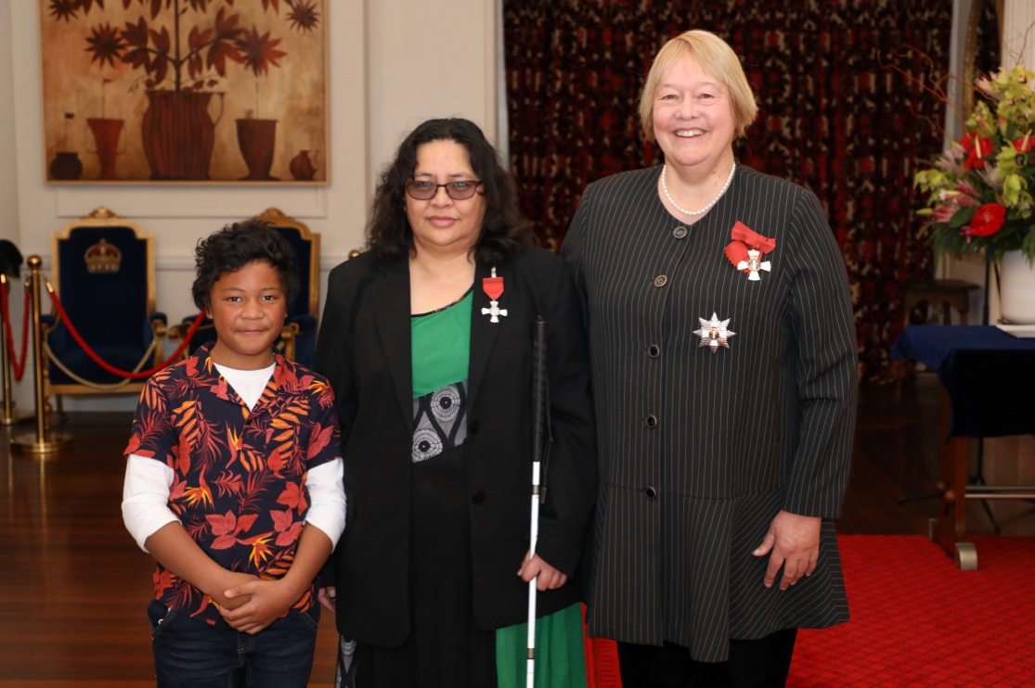

- About Us

Kāpō Māori Aotearoa (KMA) is the oldest national tāngata kāpō Māori (Māori blind, low vision and deaf blind) and national tāngata whaikaha Māori Disabled People’s Organisation (DPO) in Aotearoa. Set up by kāpō Māori and their whānau in 1983, to provide peer support and advocate for tāngata kāpō and tāngata whaikaha Māori whānau Te Tiriti o Waitangi rights.

We are whānau inclusive and diverse: pan-ethnicity, pan-tribal, pan-age, pan-disability, and provide a dual role, as a kaupapa tāngata whaikaha Māori advocate and as a government contracted Māori health and disability service provider.

Our foundation is Te Tiriti o Waitangi (Māori version), guided by traditional and contemporary Kaupapa Māori values, principles, and practices, and we are a registered Incorporated Society, under the New Zealand Charities Act 2005. We are independent, governed by a board of five, who are elected by our ‘Constitutional Tangata’ members.

We serve tāngata kāpō Māori, tāngata whaikaha Māori and whānau!

- Contact Details

- Phone our free phone: 0800 770 990
- Email us at: info@kapomaori.com (General enquiries)
- Email us at: referrals@kapomaori.com (Support services referrals)
- Facebook: https://www.Facebook.com/KapoMaoriAotearoaNZ
- Website: https://www.Kapomaori.com/

