HE PŪRONGO – SUMMER 2020
Nau mai, haere mai, whakatau mai!

Ngā mihi o te Kirihimete me te Tau Hau

Warmest greetings to our members and supporters throughout Aotearoa and Australia. Our Summer 2020 edition of ‘He Purongo’ features:

- He Rau Aroha: Stevie Stevens (1959-2020).
- Our Chief Executive: Women of Influence 2020 Finalist.
- KMA Whānau News.
- M.T.K. News.
- National Operations:
- Staff Appointments.
- Hastings Office – We have moved!
- KMA Website: KMA photos and videos Page.
- Kacey and Karena’s Smoked Pork Belly Recipe.
- What’s Happening in 2021:
- KMA, Parents of Vision Impaired NZ and University of Waikato Research Project - Call for Participants.
- KMA Biennial Conference.
- Christmas and New Year Key Dates:
- Kāpō Māori Aotearoa.
- Blind Low Vision NZ.
- Kāpō Māori Aotearoa and M.T.K. Contact Details.

We look forward to catching up with you all in 2021. Until then, have a safe and relaxing Christmas and New Year with your whānau and friends.

Mauri Ora
Chrissie Cowan
Chief Executive
- He Rau Aroha: Stevie Stevens (1959 to 2020)

E Stevie, Ka tangi moteatea te ngakau ki a koe, kua mawehe i te pai o Autahi, kua rauika atu ki tua o paerau. Whakarehu tahi atu koutou ki te huinga o te kahurangi ki te kapunipunitanga o ngā wairua.

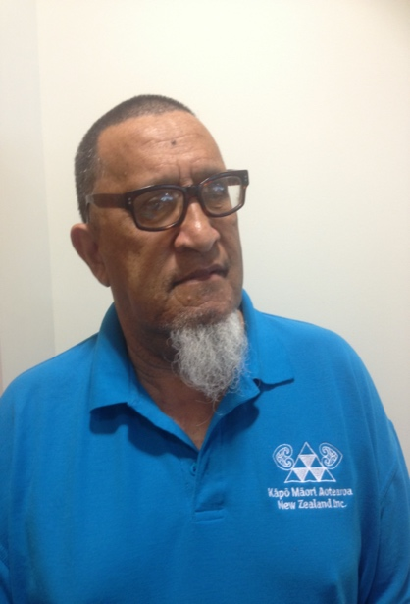
On 22 November 2020 we received the news that Stevie had passed away at Middlemore Hospital in Auckland the evening of 21 November 2020. Stevie who turned 61 years in February, had been experiencing stomach pains so took a taxi to the hospital, this action a testimony of the person he was – fiercely independent, humble and unassuming.
Photo 1: Stevie Stevens

I met Stevie through his sister Mary (Mere) Courtis in 2001, while on a work visit to Christchurch. Mere had been recruited as part of a team of five workers to implement a project to rebuild community linkages. With Mere’s husband, Tony, we had breakfast together, this starting a tradition of having breakfast with the ‘boys’ whenever I was in Christchurch.

Stevie wanted to be a chef, but after a horrific motorcycle accident, and the passing of his mother, he decided to move to Christchurch. He got a job and flatted for a while before shifting in with Mere and Tony. After Mere passed away, he moved to Hamilton spending time with his youngest brother Spencer and then relocated to Auckland and flatted with his brother Robert.

Stevie had physical and sensory impairments, one of them being deafness caused by years of working around loud machinery. On numerous occasions he would get into trouble with his sister for talking loudly, frequently getting the ‘Mere’ look! Totally oblivious he would continue to talk and laugh raucously.

His commitment to his job was legendary and despite his impairments, whatever the weather, Stevie would wear shorts and a Tee-shirt to cycle from his home in Salisbury Street, central Christchurch to his job in Woolston and home again. The exception to the rule was Friday nights when he would meet up with his mates at the local pub. At the end of the night his mates would lock up his bicycle, take him home, prop him up at the back door, knock and hightail it out of there before Mere opened the door!!

Stevie’s involvement with Kāpō Māori Aotearoa began as a member of the Otautahi rōpu. In 2005 he was appointed to Te Kahui Tumuaki, as Treasurer and after 12 years of service, Stevie retired from the Board in 2017, so to focus on his health. During his tenure, he represented the Society on several NGO and Government reference groups, the last two being the Workbridge Council and Ministry of Health, DSS Consumer Consortium. In April 2020 Stevie advised his intention to stand in the 2021 Te Kahui Tumuaki elections.

Stevie was one of those people who could talk on any subject. He enjoyed meeting people, was an avid sports fanatic and loved watching documentaries. His happy place was in front of his 45-inch television, having total control of the remote, fizzy, lollies and potato chips on hand and the sounds of the television reverberating through-out the house! With the introduction of Facebook, Stevie became quite an expert, keeping in regular contact with whānau and friends. He would also call up past board members and kaumatua just to have a chat.

My last conversation with Stevie was on 11 November when he phoned to give his apologies because he was feeling under the weather and didn’t think he would be able to attend a function the Board was hosting in Auckland. He mentioned that he was not able to move around very well but he was going to be visiting a specialist at Greenlane the following week. This appointment having been postponed due to COVID-19. He reaffirmed that he was looking forward to attending the 2021 biennial conference and that it was still his intention to stand for the Board.

Stevie was of Ngāpuhi descent. It was always his wish that upon his passing he be taken home and be laid to rest with his mother. His wish was fulfilled by his sister Cathy, brothers Robert and Spencer and his many nieces and nephews on 23 November 2020. Stevie was taken home to Kokohuia Marae, Omapere and buried in the whānau urupa near his mother, sister Mere and brother Henry on 24 November 2020.

Kua rurutu a roimata, kua maringi a hupe, ai ngā mihi me ngā tangi. Waiho mai ai te hunga ora ki muri hei urupā ora mo tana me o tana wawata, o tana moemoea.

Tenei te tuku atu rā i ngā mihi aroha ki te whānau pani a ki i pania nei e kapua pouri i marama ake nei. Ko te tumanako ka māturuhia mai e te wāhi ngaro te tōmairangi o tōna ngākau atawhai ki runga i a koutou i tenei wā.

- Our Chief Executive: Women of Influence 2020 Finalist
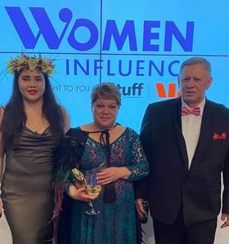
Photo 2: Chrissie, Patric & Tarewa
In September 2020 our Chief Executive, Chrissie Cowan, was announced as a finalist in the “Community Hero” category of the Women of Influence 2020 Awards for her contribution to the indigenous disability rights and Access Alliance movements. A total of 100 nominations were received for this category.

Chrissie, nominated by Brian Coffey, Director of the Office for Disability Issues said, “I was surprised when Brian asked me, and to be honest I thought he was requesting a testimonial for someone else!” After speaking with her whānau, Chrissie accepted and in September she received confirmation that she was a finalist. “I was in Auckland working when I heard from Women of Influence. Getting my head around being chosen for serving a community and initiatives I am passionate about was very humbling.” Although Chrissie did not win the category, as a finalist she was able to talk about the work of Kāpō Māori Aotearoa, indigenous disabilities rights and the vision of an accessible Aotearoa for all New Zealanders.

Reflecting on her Women of Influence journey, Chrissie said, “It was a once in a lifetime experience and a privilege to be part of such a prestigious event. My thanks to Brian Coffey for initiating the conversation with me, to my husband and daughter who encouraged me to accept the nomination and to Te Kahui Tumuaki, my staff, kaumatua, kuia and KMA members, supporters and friends for their support.”
When asked what advice she would share with future Māori women of influence nominees, she replied, “Your indigeneity is your most precious heirloom. For myself, knowing where I come from and how I belong challenges me to be the best that I can be and enables me to look to the future with hope. The other piece of advice I would offer is never let ‘can’t’ or ‘don’t’ be an excuse for allowing others to choose your pathway. Listen to those you trust and who will support you regardless of your decision and acknowledge that you may not always get it right. It is your pathway, your journey, your decision.”

The Women of Influence programme helps share the remarkable stories of women who are making a difference to the lives of New Zealanders. Each year, the awards programme shines a light on the amazing work Kiwi women are doing from grassroots level to the global stage and helps propel our future leaders and rising stars to bigger and better things. The “Community Hero” category sponsored by Massey University recognises women working in community projects or campaigns in the not-for-profit sector.

(Left to right): Back row: Jelena Zidov, Patric Cowan, Nigel Ngahiwi, Tarewa Cowan, Grant Birnie and John Mulka.
Photo 3: Group photo: Women of Influence 2020 Dinner

Front row: Raewyn Lovich, Tash Swann, Chrissie Cowan and Dianne Rogers.

- KMA Whānau News

Over the past few months, KMA staff have been able to reconnect in person with our membership around Aotearoa. Here are some stories and photos from our membership.

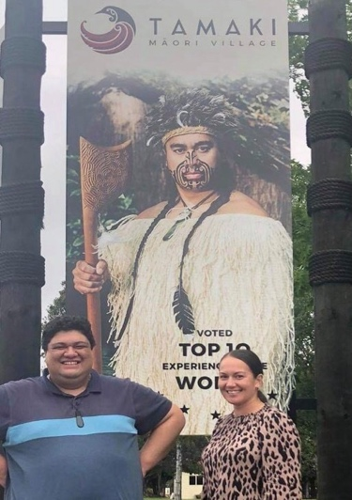
Rotorua
Photo 4: Delayne, Kiri
& Jamus Webster

Kiri and Delayne were travelling in the Rotorua area in November and managed to get a photo with Jamus Webster, one of our MCs from BC2017 – even if it was just a billboard photo of him.

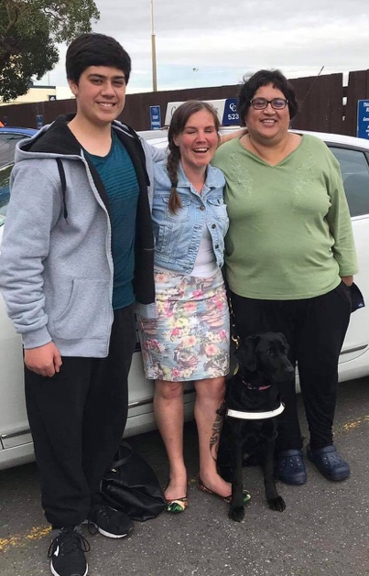
Whanganui-a-Tara
Photo 5: Caleb, Hannah & Georgina

Hannah also got to meet up with Georgina Howe and her son Caleb Young. They got to meet Hannah’s new guide dog, Dara.

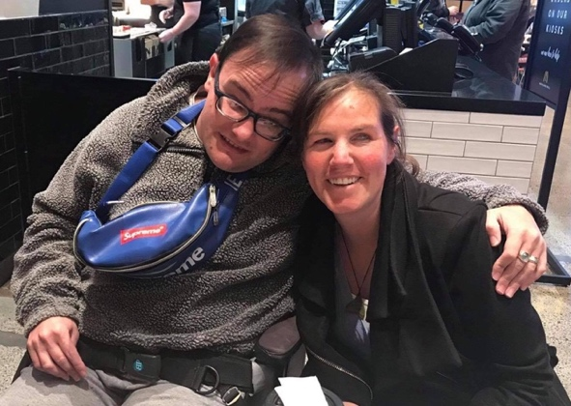
Otautahi
Photo 6 Corey Churcher & Hannah Pascoe

In October Hannah caught with Corey Churcher and his mother Jo in Christchurch. They are both excited about BC2021.

- M.T.K. News

Our M.T.K. rōpu has grown with the induction of three new members, Jason Hori from Kerikeri, Jasmine Wilson from Papakura and Zachary Coley from the Bay of Plenty.

The kaupapa of M.T.K. is to form a collective of tāngata whaikaha Māori young adults who can contribute to achieving the KMA vision and mission and share their stories to improve and create service solutions that are responsive to their age group.

To learn more about the newest members of M.T.K. and the kaupapa and work of this exciting group please head over to M.T.K’s Facebook page https://www.facebook.com/MTK-1925760917484567/

- National Operations

- Staff Appointments

We are pleased to announce that Lisa Waretini-Edwards and Tarewa Cowan have been confirmed as permanent KMA staff. Lisa accepted the new position of Customer Service and Member Registration Officer and Tarewa accepted the new position of Governance and Operations Liaison Officer. Lisa and Tarewa commenced their new roles on Monday 30 November 2020.

- Our New Hastings office

On 14 December 2020 we celebrated our move into our new office, one door down from our previous office which was cosy but had become too small. Our new office is three times the size and gives us the space to fit our growing staff.

The move went very smoothly, and all of the team were present when the office was blessed by Ngāti Kahungunu kaumatua, Jerry Owen Hapuku.

We would like to thank our landlord, Michael Smith of Ten Under Ltd for giving us the time to transition into our new office, Holly Anstruther-Burson, Hub Hawke’s Bay, Spark and Bruce McGahey, NeoCom for setting up our new Wifi capabilities and technology.

- KMA Website: KMA Photos & Videos Page

Our ‘Photos and Videos Gallery’ page is now live on our website https://kapomaori.com and the first stream of photos, Biennial Conference 2019 have been loaded. Over the following months more photos and videos, dating as far back to 1990 will be added to the page.

Only KMA Tāngata members and donors who make a financial contribution to the Society will be issued with an unique login number to access this page.

This is a new addition to the range of benefits we offer to our tāngata members and donors. Please call our freephone 0800 770 990 for more information on becoming a Tāngata financial member or KMA donor.

- Kacey and Karena’s Smoked Pork Belly Recipe

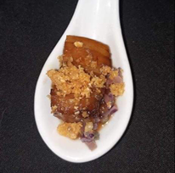
Back in 2019, Kacey and Karena Bird showcased a quick and easy smoked pork belly recipe at the Napier Biennial Conference. It was their second Kapo Māori Aotearoa conference and we are hoping they will be available to attend BC 2021 in Wellington.
Photo 7: Smoked Pork Belly

Smoked Pork Belly – (serves 4-6)

Ingredients

800 g | Pork Belly
2 Tbsp | Manuka Woodchips
4 Tbsp  2 Tbsp  ¼ Red Onion  2 Garlic cloves  2 Tbsp | Olive Oil  Salt  Diced  Minced  Butter

Directions:

- Heat oven to 150C. Ensure pork belly skin is well scored
- Ask your butcher to do this or use a very sharp knife or stanley knife
- Rub entire piece of pork belly with salt and olive oil.
- Place in a tray on a rack and cook in the middle of the oven for 3 hours.
- Remove from oven, allow to rest.
- To make a stove top smoker:
- Line a pot with tinfoil and scatter woodchips on top.
- Place a steamer inside the pot and place pork on top.
- Turn the pot on to high and once smoke starts, reduce the heat and leave the pork in the pot for 7mins.
- Remove from the pot and allow to rest before serving.
- Serve with diced red onion and garlic saluted in butter

Please send in your photos or reviews of your Smoked Pork Belly to our Facebook pagehttps://www.facebook.com/KapoMaoriAotearoaNZ

- What’s Happening in 2021

- KMA, Parents of Vision Impaired NZ and University of Waikato Research Project - Call for Participants

In partnership with Parents of Vision Impaired NZ and the University of Waikato we will be doing a small research project during January/February 2021.

The research will focus on gathering the stories of kāpō Māori and whānau about their experiences during and post COVID-19. The aim of our research is to highlight the aspirations that kāpō Māori have for themselves and their whānau, and to identify the facilitators and barriers that kāpō Māori and their whānau face in achieving these.

We will be hosting two wananga with kāpō Māori and their whānau who live in the Central North Island region. The information gathered through this project will assist Kāpō Māori Aotearoa to gather evidence that will be used to influence Government and improve the cultural and health outcomes of kāpō Māori and their whānau living in Aotearoa.

If you live in the Central North Island and are interested in taking part in this exciting project, through sharing your story, please contact us either by:

a) Phoning us (toll free): Ph. 0800 770 990. Leave your name and contact phone number; and or,
b) Putting a post on the KMA Facebook page: https://www.facebook.com/KapoMaoriAotearoaNZ ; and or,
c) Putting a post on the M.T.K. Facebook page:
https://www.facebook.com/MTK-1925760917484567/ ;and or,
d) Sending us an email: info@kapomaori.com

- KMA Biennial Conference 2021

We are pleased to advise that our 2021 conference will be hosted at the Copthorne Hotel, Oriental Bay, Wellington, 10th to 12th September 2021. Given our new COVID-19 reality we have reduced the conference programme from 3 to 2 days and limited total number of delegates to 80. As our conferences are about and for our members, KMA tāngata financial members will be given priority.

In November 2020 Te Kahui Tumuaki confirmed the conference theme as “Getting over it (COVID-19) and Getting on with it”. As expressed by our Board members, COVID-19 brought home the fragility of life battling a devasting virus, this battle still being raged through-out the world. Although Aotearoa is no longer in lock down the consequences of our new reality is filled with uncertainty. The conference theme affirms taking back our lives and determining our future.

- Christmas and New Year Key Dates

Kāpō Māori Aotearoa:

- Wednesday 23 December 2020: Hastings Office close down for Christmas. Our freephone 0800 770 990 will be monitored so if you leave a message, we will call you back.
- Tuesday 5 January 2021: Hastings Office reopens for 2021.

Blind Low Vision NZ:

- Friday 18 December 2020: Blind and Low Vision New Zealand closes down for Christmas. Their call centre Ph 0800 243 333 will be operational over the break if you should need their assistance.
- Monday 11 January 2021: Blind and Low Vision New Zealand reopens for 2021.

- Kāpō Māori Aotearoa and M.T.K. Contact Details

- Phone: 0800 770 990 (Toll Free)
- Email: info@kapomaori.com
- Website: www.kapomaori.com
- Facebook: https://www.facebook.com/KapoMaoriAotearoaNZ

M.T.K Facebook: https://www.facebook.com/MTK-1925760917484567/

