He Pūrongo – Winter 2019 (May) Edition
Nau Mai, Haere Mai!

Ngā mihi nui to our members and supporters throughout Aotearoa and Australia.
As we farewell the warmer weather and embrace the winter months, we take the opportunity to look back on some of the achievements and highlights of the year thus far from our KMA whānau and community.

This edition includes:
- Biennial Conference 2019
- Tangata Memberships
- Tamati Pearse, Journey to joining Auckland Transport
- Auckland Arts Festival and the Inaugural Te Reo Māori Audio Describers
- Staff and Event updates

Biennial Conference 2019
As announced, the Biennial Conference, will be held over three days commencing Thursday 19 to Saturday 21 September 2019.

Delegates will stay at the Scenic Circle, Te Pania Hotel and our conference will be held at the Napier Conference Centre (directly across the road), located on the stunning Marine Parade in Ahuriri, Hawke’s Bay. We have been working hard developing our programme which highlights the conference theme - Tāngata Tu, Tāngata Ora! Be Active, Be Alive!

Registrations are now open and can be done online using this link. Spaces are very limited and we encourage you to register early. The closing date for registrations is Friday 23 August 2019. https://www.surveymonkey.com/r/BC2019Member

Registration Costs
There are three options available and payments are due by Friday 6 September 2019:
- Conference Package: three nights’ accommodation, including breakfast, activities and all meals
- Conference Only: three days, activities and all conference meals
- Daily Delegate: all daily conference activities and meals

a) Conference Package Tangata Rate Non-Tangata Rate
Adults (18 - 65+ years) $550 $620
Teenagers (13 – 17 years) $150
Children (5 – 12 years) $100

b) Conference Only
Adults (18 - 65+) $400 $470
Teenagers (13 – 17 years) $100
Children (5 – 12 years) $50

c) Daily Delegate Flat Rate
One Day $150 $180
Two Days $300 $360
Three Days $450 $540
Children (5 – 12 years) $40 per day
Teenagers (13 – 17 years) $80 per day

Children aged 0 – 4 years are free of charge for the duration of the conference.

We encourage members to make use of our “Painless Payments Scheme” e.g. Tangata member registration paid weekly over 3 months (June – August) period:
Conference Package $46 per week
Conference Only $34 per week
3 days Daily Rate $38 per week

Program
This is the first time the conference will be run over three days. A full program has been prepared including the return of the Webster brothers and the Bird sisters.

We have invited some Government Ministers the Chief Human Rights Commissioner to address the delegation. On Thursday, we will commence with a Powhiri, and a presentation from Hanui Lawrence about ‘Aunty’s Garden’, a community garden project in Hastings.

On Friday, members of the First People’s Disability Network of Australia will present, followed by three concurrent workshops to cater to all age groups including: Arts and Crafts for Tamariki, 21st Century Skills for Rangatahi and a Panel for Pakeke covering the topics of: Wai 2575 and 2109 claims, IMM UNDRIP and the Access Alliance.

Kasey and Karena Bird will return to showcase Kahungunu kai, the fruit bowl of Aotearoa. Later that day, delegates will be treated to an Expo showcasing Health & Wellbeing, Technology, Māori Arts & Crafts and a small group will take to the water on an Accessible Waka Ama. On Saturday, the newly appointed members of Te Kahui Tumuaki will be confirmed at the General Meeting, followed by presenters and Haakari, entertained by the Internationally toured Kahurangi Māori Dance Theatre, and some other surprises.

Te Kahui Tumuaki General Election – Nomination
There are two (2) positions available for nomination in this general election, Vice President and Executive Member. Nomination, Election and Voting is open to Tangata members only. Nominations open on Friday 19 July and close on Friday 2 August. To nominate someone please contact Adele on 0800 770 990.

Remits and Motions to Te Kahui Tumuaki
Tangata members are invited to present motions for consideration at the General Meeting, by emailing Adele on adele.vukula@kapomaori.com. The due date is 31 July 2019.

Tangata (Financial) Memberships
Tangata Members pay the annual fee of $20 and have added benefits, especially in relation to the Biennial Conference, they include:

- Choosing how to invest your membership fee under the Three Kete of Knowledge Investment plan.
- Nominating other Tangata members to stand for Te Kahui Tumuaki board positions. Nominations are due by 2 August 2019.
- Submitting remit(s) for the General Meeting.
- Nominating Life and/or Honorary Members.
- Voting without attending the General Meeting i.e. Postal Voting.

The Three Kete of Knowledge Investment Plan allows Tangata members the option of investing in one or all three of the kete, which are:
- Te Kete Hinengaro (Mind)
- Te Kete Tinana (Body)
- Te Kete Wairua (Soul)

To find out more, register as a new Tangata member or renew your membership, contact Adele on 0800 770 990.

Governance Sustainability Wānanga
A Governance Training Wānanga will be held on Saturday 29 June in Wellington. This wānanga is an opportunity for members who are interested in learning more about being a member of Te Kahui Tumuaki, the National Executive board.

My Journey to Joining Auckland Transport
Written by Tamati Pearse, Ngati Kahungunu

My journey to Auckland Transport started after a visit to Delayne’s whare where I had my pounamu blessed by his Papa, it was a great day for me where we were able to hang out.

While I was catching the train back home, a ticket officer at Brittomart Station offered some assistance to help me out of the train as it had changed since I was shown during O&M Training. We went to find a taxi, and waited together till one arrived.

While I was waiting we got to talking about the things I get up to like Blind Sports, Achillies, Judo, Blind Cricket, my work at Dans le Noir and how I had a Telemarketing job that I’d been let go from. He was very interested in how I was able to do all those things and how the JAWS software worked.

During our conversation he said his wife was the Group Manager of Customer Services at Auckland Transport, and would talk to her about any job opportunities. Two weeks later I received a phone call from her, asking what call centre experience I had and why I’d finished my last customer service job. She reassured me Auckland Transport had no expectations on sales targets as my previous employer and they’d never had a kāpō employee before, there would be learning for both of us.

In preparation for a potential job, I contacted Employment and Technology Consultants at the Blind Foundation to organise some supports, especially how to use JAWS in the workplace. On my way to the interview, I couldn’t believe this was happening, and was supported by the Employment Consultant who could answer the questions I didn’t know. The interview went well, and while they figured out what I could do there, I was invited in for a few hours to explore the contact centre and sit with workers to gain some insight.

After a month I got the call, they were offering me a part time position. I hung up and paused, my mind was going in circles, did this just happen? I got the job! I was involved in the building inspection, looking at my workspace and any potential hazards. Usually the staff use hot desks and move around, but I was assigned a permanent desk due to my equipment and mobility.

I started work after returning home from the New York Marathon, and they had everything set up for me, including a buddy to show me the ropes. Five months on, I am a Customer Service Specialist, am doing very well and have learned heaps from when I began, and will soon be going up a level.

Auckland Arts Festival 2019: The Introduction of Te Reo Māori Audio Description
Written by: Chrissie Cowan
Photo: Te Hamua Nikora, Patric Cowan, Jamus Webster
Source: Outlook Magazine, Blind Foundation

The Auckland Arts festival ran from 7 to 24 March 2019. The festival’s programme celebrates the richness of Aotearoa New Zealand arts and culture, showcasing both local and international events.

The commitment of the Auckland Arts Trust to make festival events accessible to all audiences is reflected not only in the programme but also in the production and delivery of events.

In September 2018, Kāpō Māori Aotearoa agreed to identify fluent te reo Māori speakers interested in training as audio describers to audio describe in Te Reo Māori the production of the Patricia Grace and Robyn Kahukiwa children’s story “Te Kuia me Te Pūngāwerewere—The Kuia and the Spider”, which was performed by Taki Rua Productions at BLENNZ on 21 March 2019.

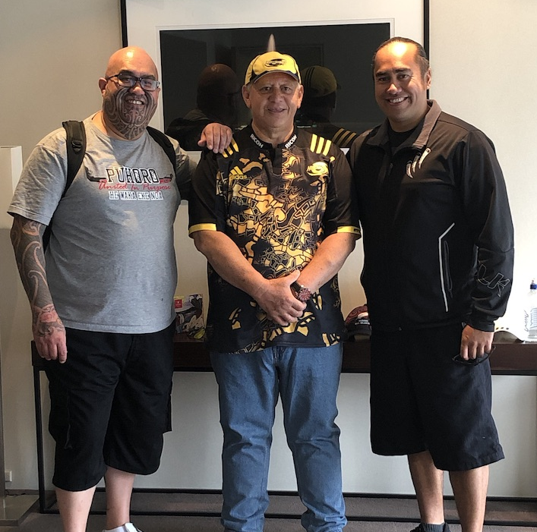
In December we were pleased to confirm Jamus Webster and Te Hamua Nikora as our inaugural trainees. Jamus and Te Hamua are staunch supporters of Kāpō Māori Aotearoa and stalwart advocates of Māori performing arts, te reo Māori and all things Māori. Having trained te reo Māori audio describers is a significant milestone for our community and a positive step towards making te reo Māori and te ao Māori more accessible for not only our members but also the entire kāpō community.

Kāpō Māori Aotearoa would like to acknowledge the Auckland Arts Trust and their team for their commitment of making te reo Māori and festival events accessible.

The performance at BLENNZ was reported on Maori Television. Search ‘New play in te reo Māori for blind tamariki’ on their website.

WHAT WE’VE BEEN UP TO…
- Staff Training
The Operations Team held a staff training in Auckland during March. During this time, we met with Blind Foundation Staff to find ways of working together to provide smoother and streamlined services to our members. We also attended two events from the Auckland Arts Festival – A Man of Good Hope that was Audio Described and Toku Reo Waiata which showcased the biggest Te Reo Performers in Aotearoa.
- New Staff Member
We would like to introduce Kiri Hill, who has joined the KMA Operations Team as a Tangata Whaikaha Kaimahi (Hapori Māori), based in Hastings. She has made a smooth transition into the team and is looking forward to meeting the wider KMA whanau at the Biennial Conference.
- Surveys
the Disability Information and Advice (DIAS) and Specialist Maori Cultural Support surveys are being conducted during May and June, to help us provide a better service to our members. If you would like to provide some feedback, please get in touch.

What’s Coming Up
- 16 May – Regional Hui, Christchurch
- 17 May – Regional Hui, Invercargill
- 22 May – Staff Training, Auckland
- 25 May – Board Meeting, Hastings
- 8 June – MTK Hui, Hastings
- 29 June - Governance Sustainability Wānanga (subject to change)
- 19 July - Te Kahui Tumuaki Board Nominations Open
- 31 July - Remits and Motions Due
- 2 August - Te Kahui Tumuaki Board Nominations Close
- 23 August - Conference Registrations Close
- 6 September - Conference Payments Due

