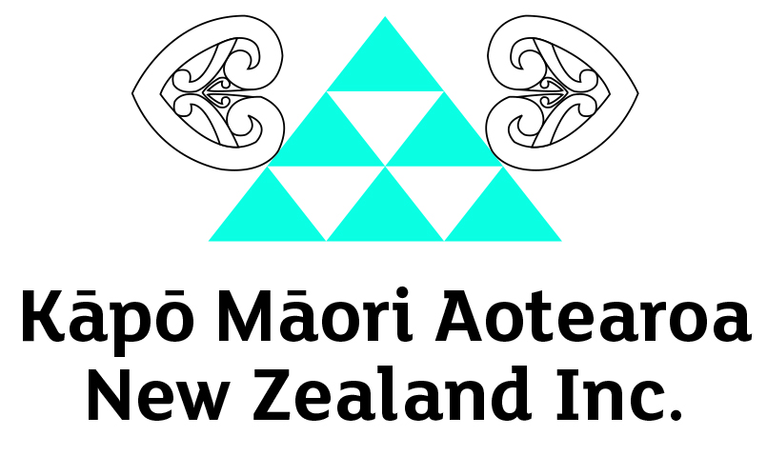

He Pūrongo – Summer 2018 Edition
Nau Mai, Haere Mai!

Ngā mihi nui to our members and supporters throughout Aotearoa and Australia.
As we approach the Christmas and New Year, we look back on some of the achievements and highlights of 2018 from our KMA whānau and community.

This edition includes:
- Cora’s Retirement
- Tamatea Chambers, Making New Zealand History
- Government Signs off on Accessibility Work Plan
- Nga Rõpu o Manaaki Tangata Kotahitanga (M.T.K.)
- Disability Action Plan Review Consultation
- Biennial Conference 2019
- Staff and Event updates

Meri Kirihimete me te Hape nū Ia (Merry Christmas and a happy New Year) to you all. We hope you enjoy the contents of our last panui for 2018 and look forward to catching up with you in the new year. If you would like to know more or share your experiences, please get in touch by phoning 0800 770 990.

Cora’s Retirement
Photo: Cora, on the beach

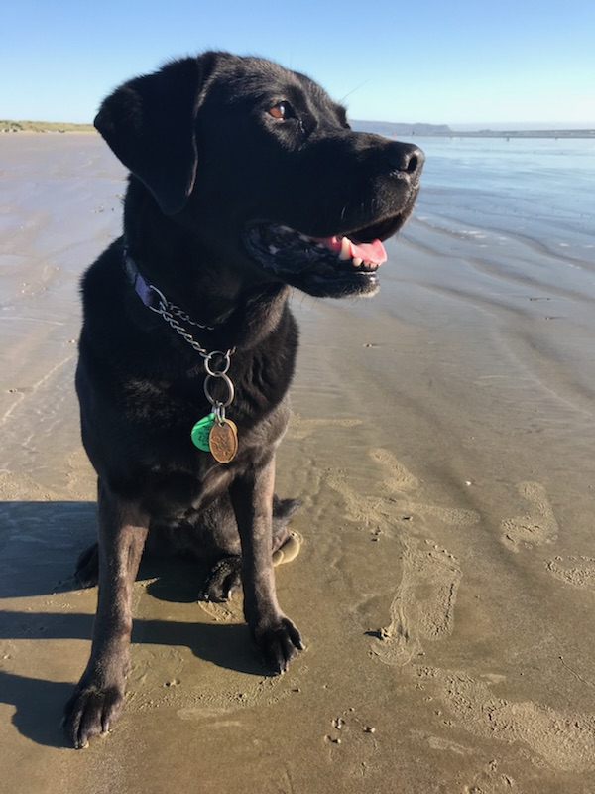
After seven years of service to Hannah Pascoe and Kāpō Māori Aotearoa, Cora has officially retired! During her time she travelled to all four winds of Aotearoa leaving her mark on everyone she met.

Her spirit will be missed within the KMA whanau and community.

She’s now living it up in the Waikato as a dog of leisure and mentor to a guide dog hopeful.
Making New Zealand History
Written by Tamatea Chambers.
Photo: Tamatea Chambers, holding his Gold Medal.

Kia Ora, my name is Tamatea Chambers and I am a member of Kāpō Māori Aotearoa NZ. In July 2017, my Father thought it would be a good idea for my brothers to join Taekwondo, as they were getting into fights at school and he also thought it would be a good idea for them to learn self-discipline.

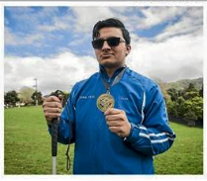
I said I wanted to do it so, if I was to join I was the one who should pay for all of us. When we first started I found it a struggle as I am visually impaired, so the Masters and I figured out ways for me to learn the different kicks, self-defence and punches, starting with a white belt.

After my first grading, I received a yellow belt and progressed through to green belt. After a year of hard training and learning to fight, I decided to enter the Taekwondo Union of New Zealand Invitational Championship. The competition was held on 29 October 2018 at Te Rauparaha Arena, Porirua.

When I registered I thought it’d be hilarious if I entered and was to beat my opponent, knowing that I’m visually impaired. On the day of the tournament I was really nervous, thinking I had no chance. The time came and it was my first round when I had scored 4-0, the second round scored 8-0, and in the final round I was penalised giving my opponent points. At that point I was really nervous, thinking I had no chance, the final bell rang and the score was 10-3.

In that moment I was so proud as I had made New Zealand history be becoming the first legally-blind person, to win Gold in sparring and take out the division I had entered, in the biggest Taekwondo organisation in the country, spanning more than 30 clubs and 800 enthusiasts.

My goal is to train really hard and one day go to the Paralympics, and bring home the GOLD!

Government Signs Off on Accessibility Work Plan
Source: www.beehive.govt.nz
Photo: Members of the Access Alliance with Minister Sepuloni

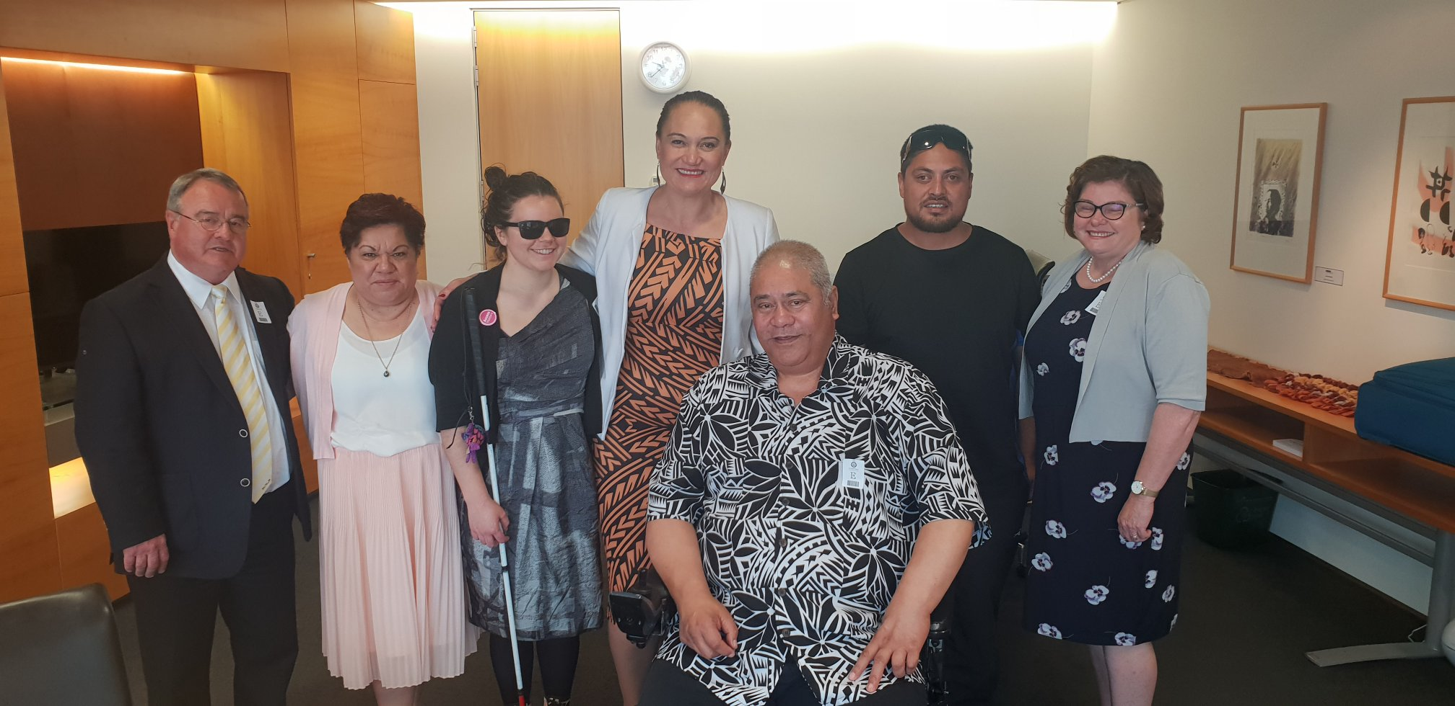

On 6 December 2018, Minister for Disability Issues, Carmel Sepuloni announced that Cabinet had approved a work programme to thoroughly explore how we can achieve full accessibility for disabled people and all New Zealanders.

The work programme will focus on accessibility for disabled people but will also look at how we can improve accessibility for other groups such as seniors, carers of young children, people with English as a second language, and those with temporary injuries.

The work programme will involve collaboration with a wide variety of stakeholders, including the Access Alliance, other disability groups and small business. It will look at:
- how to define “full accessibility”
- the challenges and opportunities of different approaches
- whether legislation is needed for mandatory codes and standards for accessibility and what domains any might cover.

“A lack of accessibility to transport, information, communications and customer services creates barriers to employment, housing, education and to a decent standard of living and quality of life.

“A quarter of New Zealanders including seniors are disabled. With a rapidly ageing population, we need to start work now, so that all New Zealanders and future generations can participate fully in society.

“Over 25 % of disabled people are underemployed compared to 11.5 % of non-disabled people. Many disabled people are qualified to work but they’re excluded from employment because things like transport, buildings and services aren’t accessible.

“In this day and age that level of exclusion for such a big proportion of our society is unacceptable. These barriers must be broken down,” Carmel Sepuloni said.

Chrissie Cowan, CEO of Kāpō Māori Aotearoa and Chair of the Access Alliance says: “On behalf of the Access Alliance, we applaud the government on this decision, and thank Minister Sepuloni for listening to New Zealanders with disabilities and taking action.

“All New Zealanders deserve an equal footing to enable us to do the things we want to in life. For too long barriers that may be invisible to others, such as the absence of environmental cues in public spaces to help vision-impaired people know where they are, have been standing in the way.

“Universal access will enable everyone to contribute more to society and create economic benefits such as making our country more accessible for the one billion potential tourists with access needs. The opportunity is huge, and the future is exciting,” said Chrissie Cowan.

To view the announcement during Question time, the link is: https://youtu.be/dM_-DPtRsGs

Nga Rōpu o Manaaki Tangata Kotahitanga (M.T.K)
In May 2018, the name was determined: Nga Ropu o Manaaki Tangata Kotahitanga (M.T.K), meaning people helping people however possible, acknowledging that impairments don’t define who they are and uniting the kapo community together as one whanau.

The ropu of young adults with vision impairment was formed for all young adults with disabilities to come and share ideas and opinions with KMANZ, e.g. improving the services and to have more input towards future planning of events, hui, trips, activities and conferences. M.T.K. will work together with KMANZ to help make the world more accessible for all those living with a disability, nga Tangata Whaikaha o Aotearoa.

“Since joining M.T.K, I know I have found and made friends that will understand my struggles in life. Through M.T.K, I have and will experience new things in my life.” Tash Swann, founding member.

“Forming M.T.K, and joining Kapo Maori Aotearoa has been the biggest highlight of my life thus far. Straight away our group share a bond like no other because of our disability, we click. I used to feel like a no-hoper. Now I have more belief in myself and what I can do because of the support they've given makes me feel I can do anything. Whanaungatanga is what we're all about!” Wiremu Kohere, founding member.

You can follow their ‘intro video’ and journey on their Facebook Page by searching “M.T.K.”, they’ll also be regularly contributing to He Pūrongo.

Biennial Conference 2019 Update
We are pleased to announce that the Biennial Conference, for the first time, will be held over three full days commencing Thursday 19 to Saturday 21 September 2019. Please note the change of date that was previously announced.

Conference delegates will be housed at the Scenic Circle, Te Pania Hotel and activities held at the newly refurbished Napier Conference Centre, along the stunning Marine Parade, Napier.

The Operations Team are brainstorming ideas for activities and presenters to showcase Kahungunu and it’s offerings. Te Kahui Tumuaki endorsed the Conference Theme: Tāngata Tu, Tāngata Ora! Be Active, Be Alive!

Registration Costs will be announced in 2019, however you can begin putting away some putea using our ‘Painless Payments’ scheme, to find out more contact 0800 770 990.

Disability Action Plan Consultation
Photo: Members of M.T.K with Te Hamua Nikora and Chrissie Cowan

On Saturday 24th November 2018, KMANZ in partnership with the Office for Disability Issues, hosted the tangata whaikaha Māori and whānau focused consultation hui at Te Taiwhenua o Heretaunga, Orchard Road, Hastings, with Te Hamua Nikora as the facilitator.

These hui are key to provide a safe platform to ensure the voice of tangata whaikaha Māori, whānau members and the disability community are heard during the consultation process and the renewal of the New Zealand Disability Action Plan.

The next consultation hui will be held in Tairawhiti, Gisborne in March 2019.

WHAT WE’VE BEEN UP TO…
- Staff Training
The Operations Team held a staff training in Auckland during September, shadowed by M.T.K. founding member, Wiremu Kohere. During this time, we met with the organizers of the Auckland Arts Festival which will be held during 7 – 24 March 2019 all around the city. There are a number of accessible events catering to Blind, Low Vision, Deaf, Hard of Hearing and Touch Tours. Please check out their site for more details: www.aucklandfestival.co.nz or their Facebook page: Auckland Arts Festival.

- MOH Disability Information and Advice Service (DIAS) Survey
A sample of 110 members were randomly selected and invited to provide feedback about their experiences in accessing national disability information and advice services to kāpō Māori and their whanau, especially the Tāngata whaikaha community and general public during July 2017 and June 2018. Some of the feedback includes:
  - 71% of participants stated that the communication skills were to a high standard;
  - 98% of participants stated they preferred contact to be made by Phone calls, followed by text messages
  - 68% of customers who accessed the service rated the information and advice received were above average.

- MOH Specialist Maori Cultural Support (DSS) Survey
This survey is about the performance of KMA to assist members and whanau to access and engage Blind Foundation specialist vision services and local community health and disability services during July 2017 and June 2018. A sample of 80 members were surveyed, a few stats include:
  - 93% of participants stated it was very important to them to have the support of a Māori organization;
  - 72% of participants rated Large Print as their medium preference, followed equally by Email and Daisy CD at 10%;
  - 83% of participants felt Tikanga Māori principles of Kia awhina, Kia manaaki, Kia tautoko and Kia aroha were upheld during their visit; and
  - When asked for one word to describe how they felt about engagement with KMA, the most four popular words were, Ka pai, Awesome, Supportive and Informative.

What’s Coming Up
- 21 December – Offices close down for Christmas
- 7 January 2019 – National (Hastings) office Opens
- February, Te Kahui Tumuaki Meeting, phone conference
- 9 March – Disability Action Plan Consultation, Gisborne
- 14-17 March – Operational Staff Training, Auckland

