HE PŪRONGO – SUMMER 2019

Tēnei te mihi ki a koutou katoa. Nau mai, haere mai, whakatau mai.

Warmest greetings to our members and supporters throughout Aotearoa and Australia. This edition of ‘He Purongo’ features news about our:

- Biennial Conference 2019:
  - Te Kahui Tumuaki 2019 to 2021 Election results
  - ‘Kahungunu Kai’ - Recipe #1
  - Biennial Conference 2021.
- Facebook, Website and TIS revamp.
- Staff Movements.
- 2020 Events.

Te Kahui Tumuaki and our team have enjoyed receiving calls, emails and text messages from our Kāpō Māori Aotearoa (KMA) whānau. Thank you for the messages of support, attendance at regional and national hui, taking the time to post on the KMA Facebook page, listening to our updates on TIS and visiting our website.

In 2020 we want to share more stories about the achievements of our members and supporters. If you would like to know more or wish to share your story, please get in touch by phoning 0800 770 990 or by emailing your stories to delayne.tutemahurangi@kapomaori.com.

We hope you enjoy the contents of our last panui for 2019. We look forward to your continued support, participation and attendance at KMA events in 2020.

Ngā mihi nui,
Chrissie and KMA team.

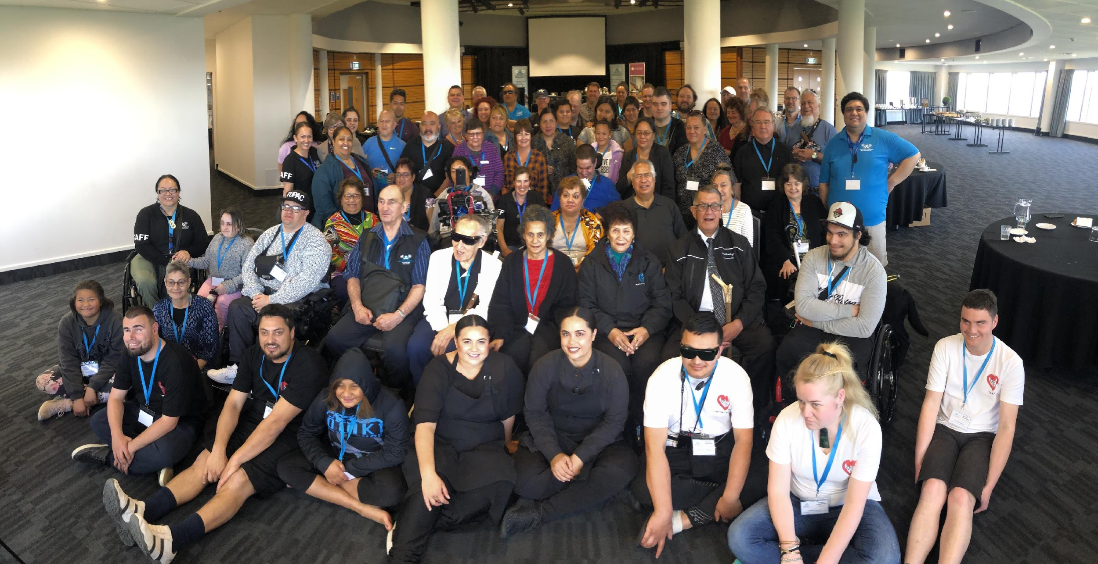
BIENNIAL CONFERENCE 2019
Photo 1: Group Photo of Attendees at the Napier Biennial Conference 2019

It was an honour and privilege to host our members and supporters at this year’s Biennial Conference in Ahuriri (Napier). We had some amazing speakers, fantastic entertainment, our expo day was a great success and we’re sure no one went hungry with all the kai we had to share.
We were overwhelmed with the amount of positive feedback received from attendees, the contribution and goodwill of our Hawke’s Bay suppliers and sponsorship from Te Puni Kokiri and the Ministry of Health.

Congratulations to Joanne Churcher, the winner of our Grand Prize draw, BC2021 conference package and travel. Photographs and videos from this year’s Biennial Conference are currently being developed for our website, www.kapomaori.com, and an update to when they go live will be sent out to our membership.

Te Kahui Tumuaki 2019 to 2021

The KMA General Meeting held on Saturday, 21st September in Ahuriri, We bade farewell to Lance Girling-Butcher who had made the decision to retire, after six years of diligent service to the Society. Lance, who was unable to attend in person conveyed his farewells via an audio message which received a rousing round of applause. We wish Lance, Allie and Yogi all the best for the new year.

The 2019 to 2021 Te Kahui Tumuaki election results were announced and we congratulate Natasha Swann on her appointment and Nigel Ngahiwi on his re-election as Vice President. The 2019 to 2021, Te Kahui Tumuaki members were confirmed as:

- Gayelne Te Rauna, President
- Nigel Ngahiwi, Vice President
- Raewyne Lovich, Executive Member
- Poihaere Morris, Executive Member
- Natasha Swann, Executive Member

‘Kahungunu Kai’ Recipe #1 - Salmon and Vermicelli Salad with a Thai Dressing: Kasey and Karena Te Awa-Bird

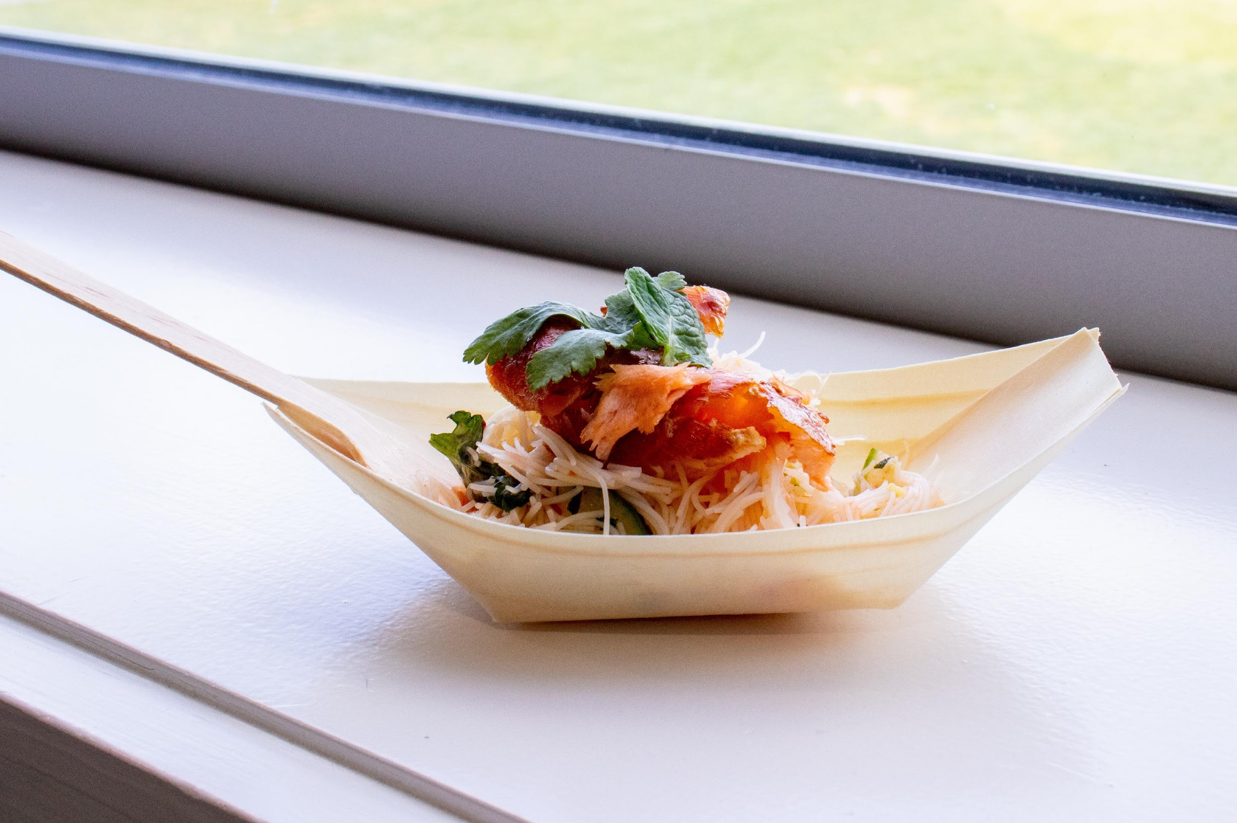
Members, supporters and guests were, once again, captivated when Kasey and Karena prepared delicious morsels from recipes that they have created exclusively for BC2019. Special thanks to Kasey and Karena for sharing yourselves and your talent with us. We look forward to tasting your mouth-watering kai at BC2021!
Photo 2: Salmon and Vermicelli Salad with a Thai Dressing

Here is the first recipe for you to try at home. Kia manahau!

Salmon and Vermicelli Salad with a Thai Dressing – (serves 4)

Salad:
250 grams | Dried Vermicelli Noodles
 | Assorted Seasonal Vegetables – sliced and prepped
½ | Cucumber - deseeded and sliced thinly
2 | Spring Onions – thinly sliced
1 Bunch | Coriander Leaves – chopped, save stalks for Dressing
1 | Red Chilli – deseeded and sliced thinly

Dressing:
1 Bunch | Coriander, Stalks only – saved from Salad ingredients
3 cm | Fresh Ginger – peeled and chopped
1 clove | Garlic
¼ cup | Sweet Chilli Sauce
1 | Lime, juiced
1 Tablespoons | Fish Sauce
1 | Red Chilli – deseeded and chopped
2 Teaspoons | Sesame Oil

To Serve:
450 grams | Smoked Salmon

Directions:
- For Dressing:
  - In a small food processor, whizz together the dressing ingredients.
  - Add water if it is too thick.
- For Salad:
  - Cook the vermicelli as per the packet instructions.
  - In a large bowl; mix together the remaining salad ingredients and add three-quarters of the dressing.
  - Add the drained vermicelli.
- To Serve:
  - Arrange the noodle salad on a platter and flake the salmon over the top.
  - Pour remaining dressing.
  - Add chopped coriander leaves to serve.

Send your photos or reviews of your Salmon and Vermicelli Salad to our Facebook page, https://www.facebook.com/KapoMaoriAotearoaNZ.

Biennial Conference 2021

The last item on the General Meeting 2019 agenda was to confirm the location of our next conference. We are pleased to announce that Biennial Conference 2021 will be hosted in Wellington during the month of September.

KMA FACEBOOK, WEBSITE AND TIS REVAMP

We are currently updating our Facebook page and Website – some of you may have already noticed some changes. Over the coming months we will be introducing new pages on our website, which will include photographs and videos going as far back as 1990 to current day. TIS will also be updated in the new year. Check our Facebook page for more information.

KMA STAFF MOVEMENTS

In June 2019, Lisa Edwards and Tarewa Cowan formally joined the Kāpō Māori Aotearoa operations team. Lisa and Tarewa are not new to KMA or our members, both working as Mahi Aroha on different projects. Lisa will maintain contact with members and service users and conduct our customer satisfaction surveys. Tarewa will provide support to Ngā Rōpu o Manaaki Tāngata Kotahitanga, (MTK), Te Kahui Tumuaki and assist in the implementation of regional and national projects.

In September 2019 we said goodbye to Adele Vukula and Horiana McGregor. Adele had been with us since 2014 and Horiana since 2015. We thank them for their service to KMA and we wish them well in their future endeavours.

Event Updates
- Friday 20 December 2019 – Hastings Office close down for Christmas. Our freephone 0800 770 990 will be monitored so if you leave a message, we will call you back.
- Tuesday 7 January 2020 – Hastings Office opens.

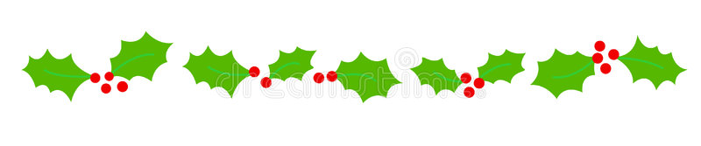

Meri Kirihimete me te koa o te Tau Hou ki a koutou katoa
Merry Christmas and a Happy New Year to you all.

Te Kahui Tumuaki me ngā Kaimahi o Kāpō Māori Aotearoa.

